CS 255 System Design Document Template

UML Diagrams

UML Use Case Diagram
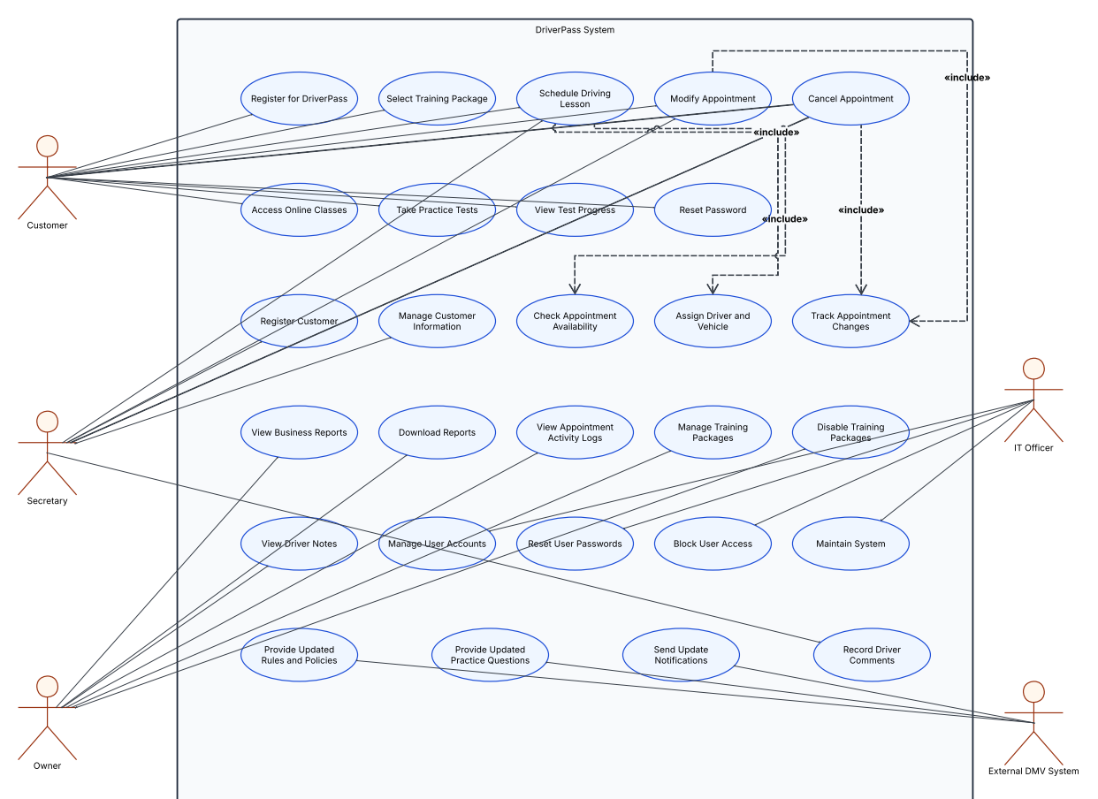

UML Activity Diagrams
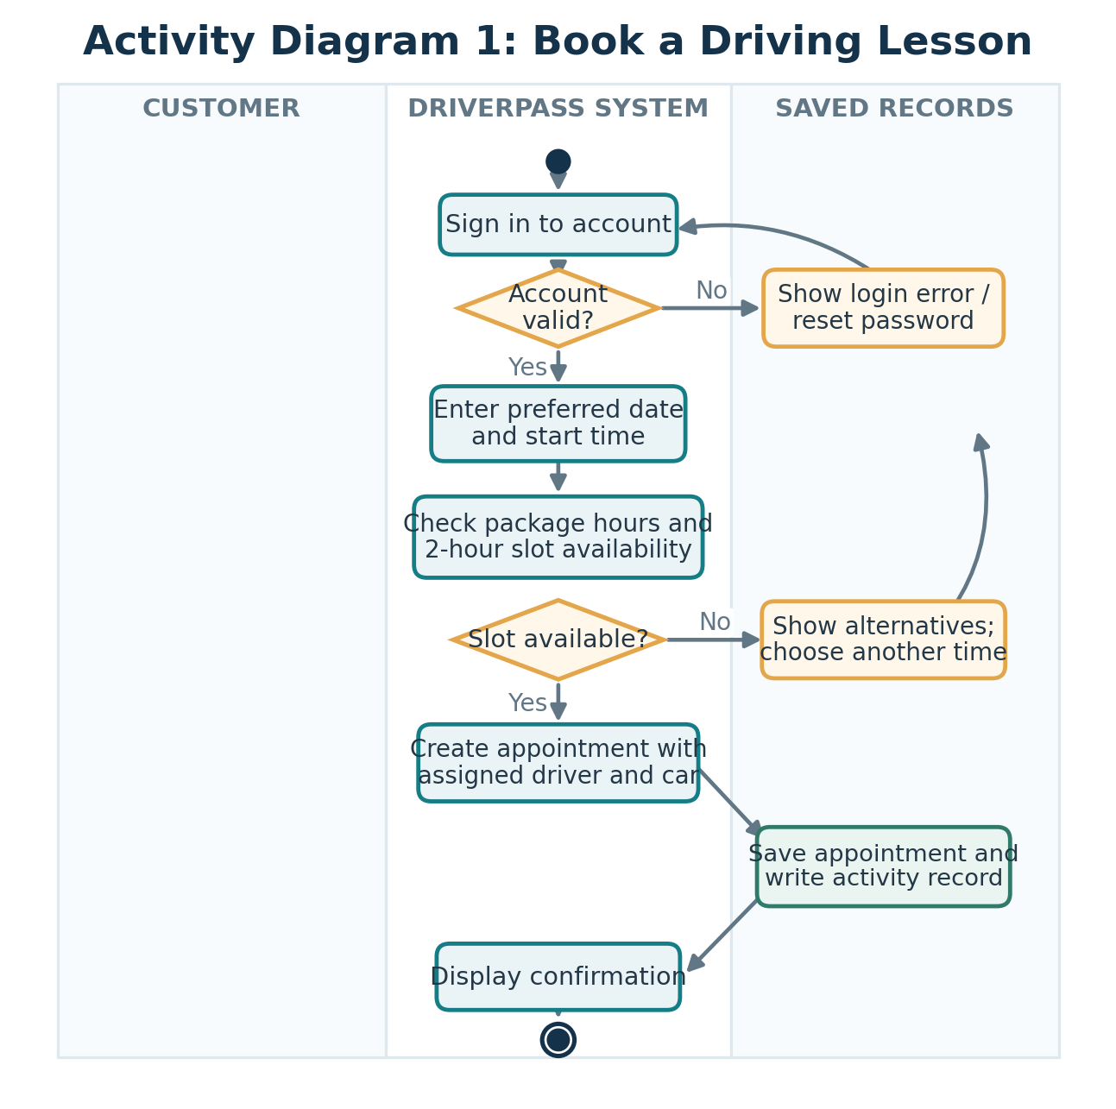
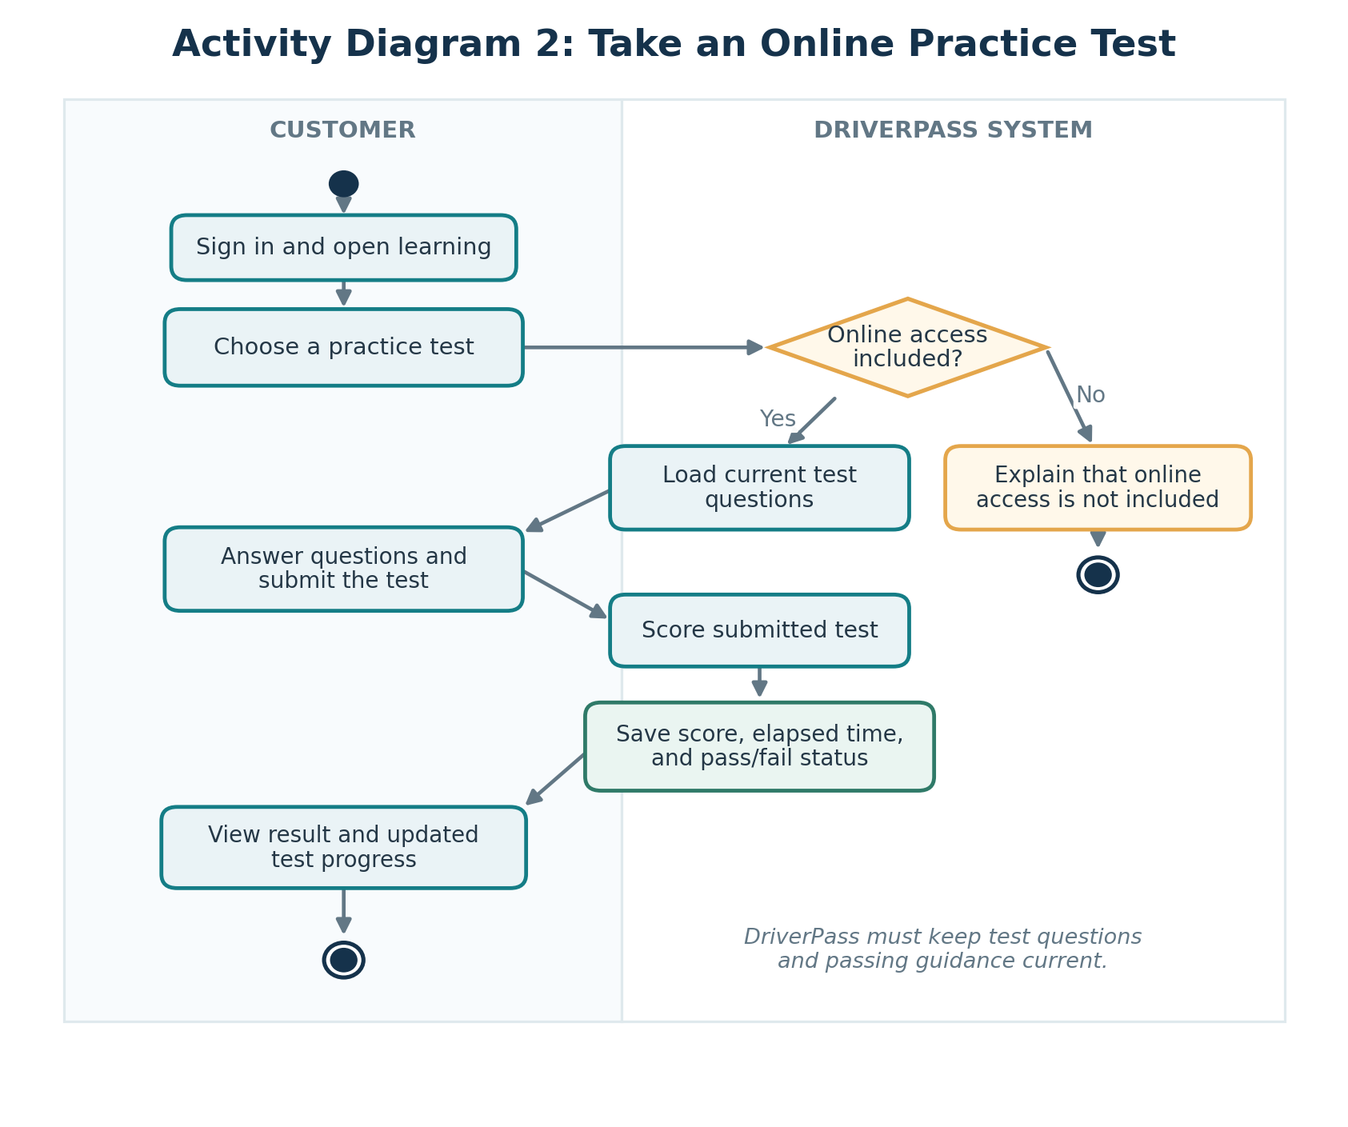

UML Sequence Diagram
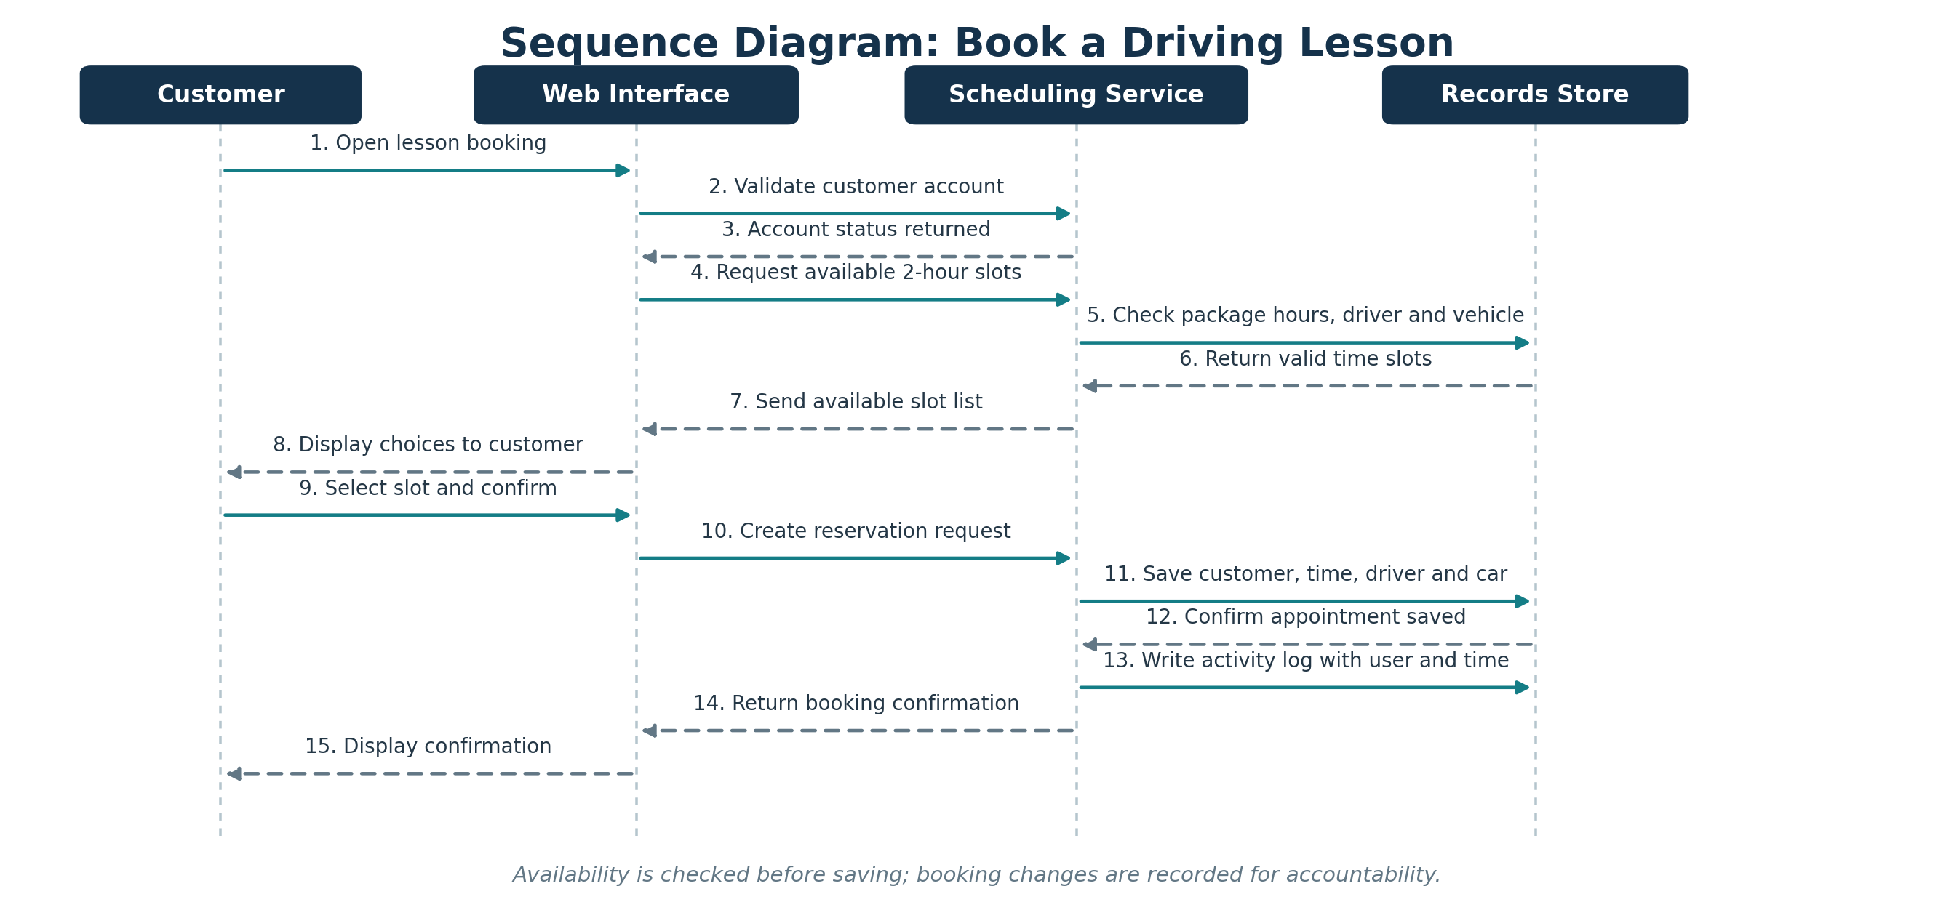

UML Class Diagram
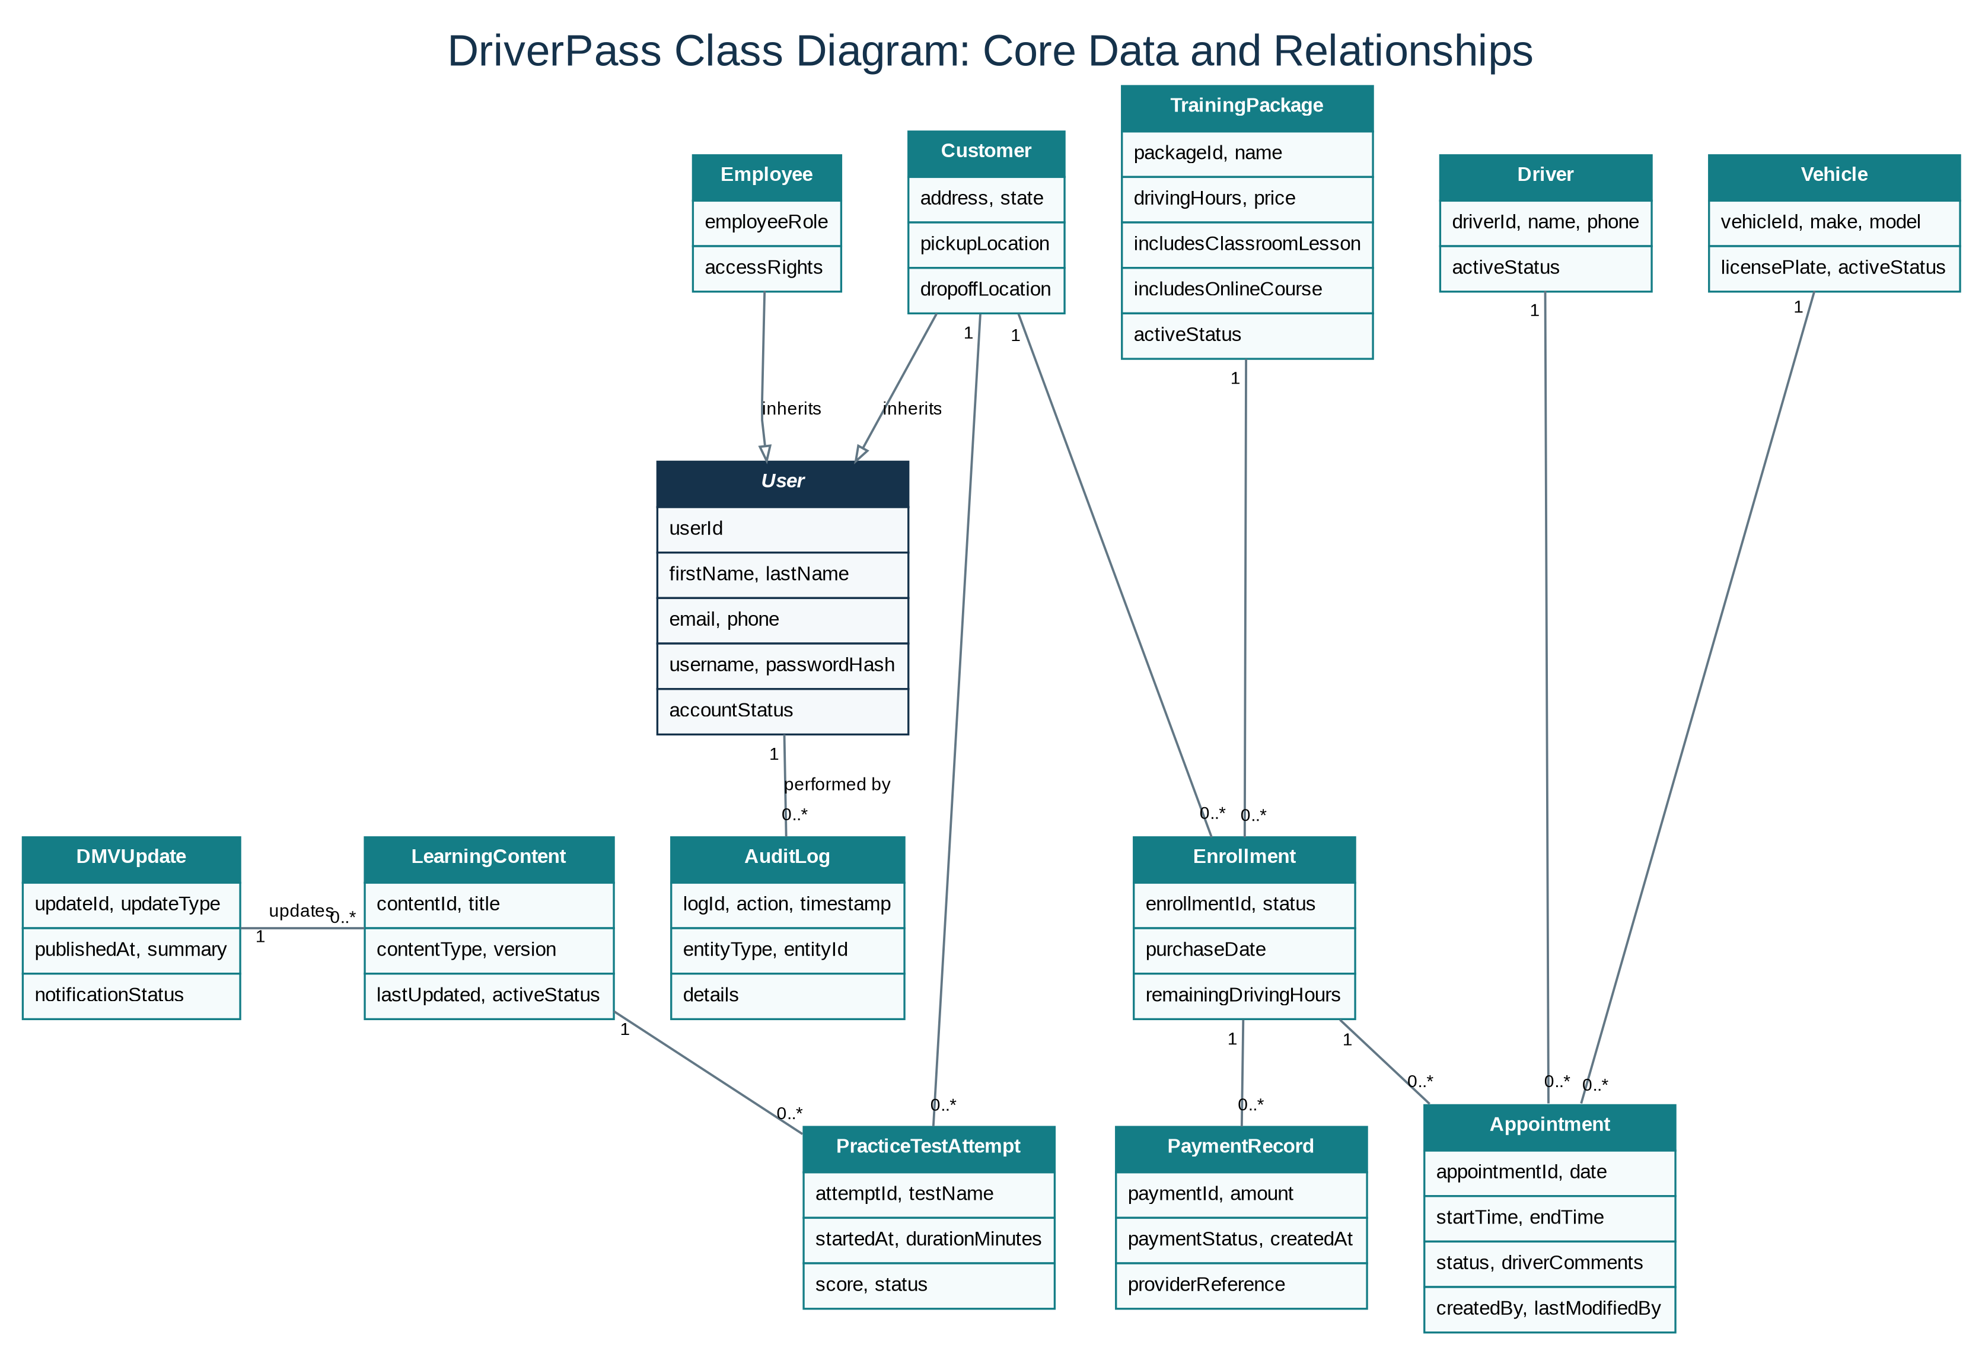

Technical Requirements

Hardware
• Access to the internet is required through the use of computer, tablet or mobile phone for both customers and employees.
• For the DriverPass, cloud computing technology will be required to store information about customers, bookings, trainings and reports.
• Computer access in the office will enable the secretary and the owner to manage customers and appointments.
Software
• Web application that is responsive both on computers and on mobile phones.
• Database system to store data of customers, employees, accounts, training packages, appointments, assignment of drivers and vehicles, practice test results, and activity tracking system.
• Secure user login, password recovery, and access system for users including the customers, employees, owner, and IT officer.
• A scheduling system to prevent any scheduling conflicts and to log 2 hours of driving classes.
• Online classes and practice tests that log scores, progress, and amount of time spent on each test.
• Reporting tools to enable authorized users to download activity and business reports.
• Payments processing and updating the DMV, depending on the availability of compatible external tools.
Tools & Development Environment
• Lucidchart for creation and maintenance of UML diagrams.
• Tools for development and testing of the software to create the application, test its functionality and fix any bugs prior to the release.
Infrastructure & Security
• Cloud-based hosting of the web application and database.
• Encrypted communication and secure storage of sensitive data.
• Regular backups to avoid losing data.
• Role-based permissions and logging to protect data and keep track of appointments' changes.
• Monitoring of the system to detect problems with its services and integrations.
Limitations & Assumptions
• A working internet connection is needed to update customers' data and their appointments.
• Automatic DMV updates depend on the DMV providing a supported connection or update service.
• The owner can deactivate training packages, but adding new system features will require developer assistance.
• The initial system will support the three training packages described by DriverPass.
• Scheduling accuracy depends on keeping appointment, driver, and vehicle information up to date.
Conclusion
In the proposed DriverPass program, clients will be able to get their training materials, practice test and even arrange their driving lessons online. The program will also assist the staff in making appointments, protecting client data and making necessary changes. The design combines these functions with a central database and cloud hosting to support DriverPass's business needs.

